31. Talbot Method for Strain Analysis
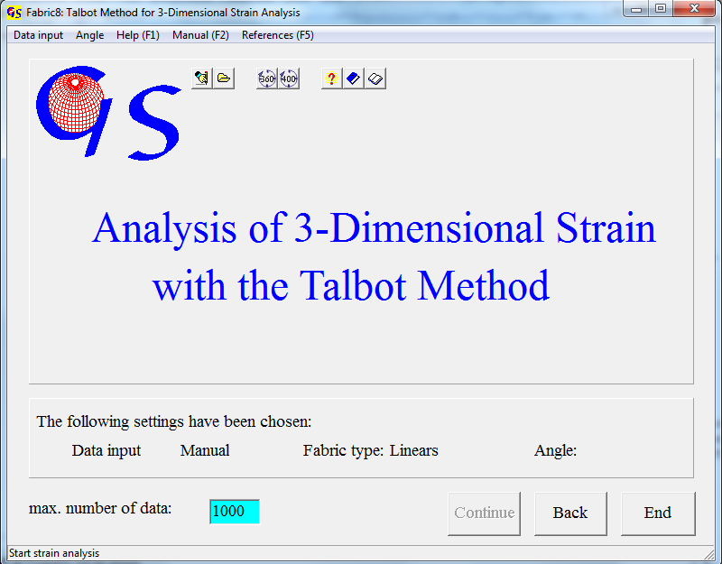Fig. 1

This program carries out a strain analysis and the plot of a Flinn diagram from orientation data of elongated (boudinaged) and shortened (folded) markers, i.e. intersection of veins with outcrop surfaces (Talbot, 1970).
Manual data input is done with direction of dip and angle of dip. The input from data files is the same as in all other programs. For shortened linears (compression) the input of azimuth is negative (Fig. 2).
Fig 3 shows the the data plot. Red dots are elongated linears; blue ones are shortened.
Between data of elongation and shortening there is an elliptical cone with “no finite elongational strain (n.f.l.s)”.
In the panel “within the n.f.l.s. ellipse” (Fig.4) click on “Shortening” when shortened linears are in the n.f.l.s. ellipse, or on “Extension” when the elongated linears are in this ellipse, as in Fig.3. Then click on “OK”.
Now Fig.5 appears, which shows the three axes of the strain ellipspoid, calculated as eigenvectors (X > Y > Z), and you are requested to click on one end of the long diameter of the n.f.l.s. ellipse, and then on one end of the short diameter.

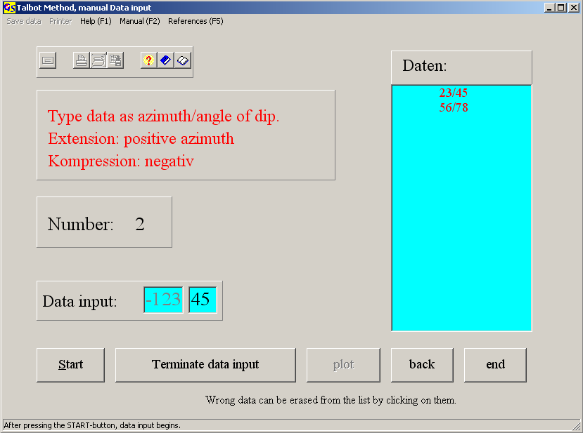
Fig. 2

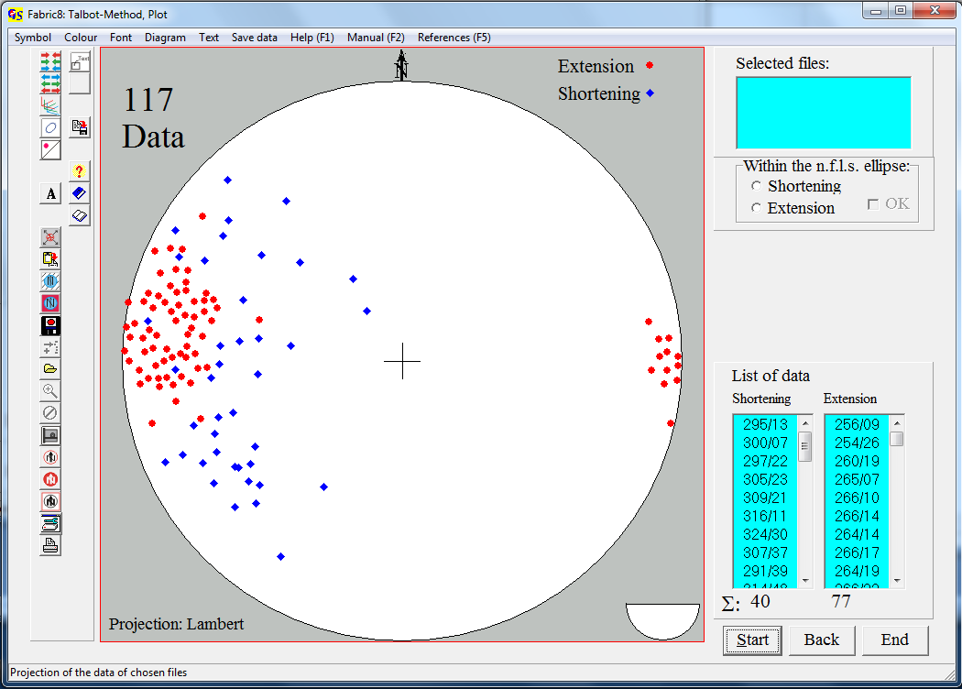
Fig. 3

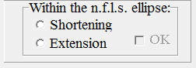
Fig. 4

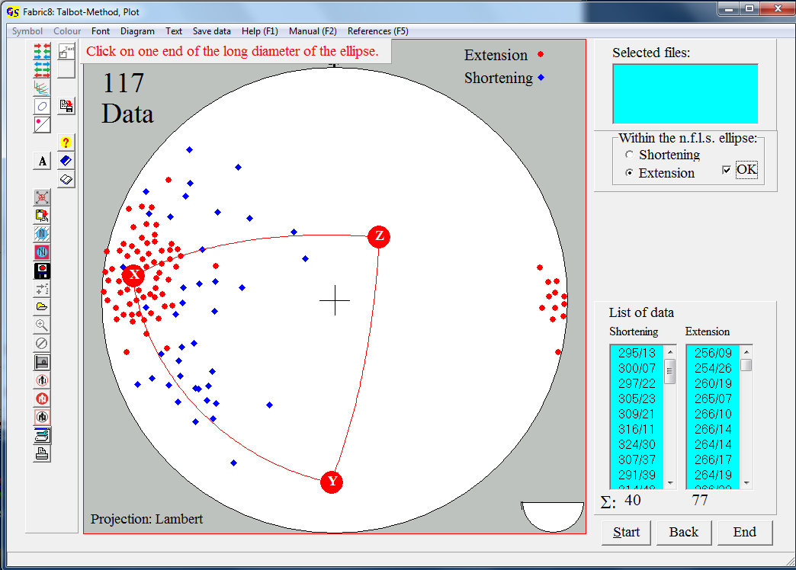
Fig. 5

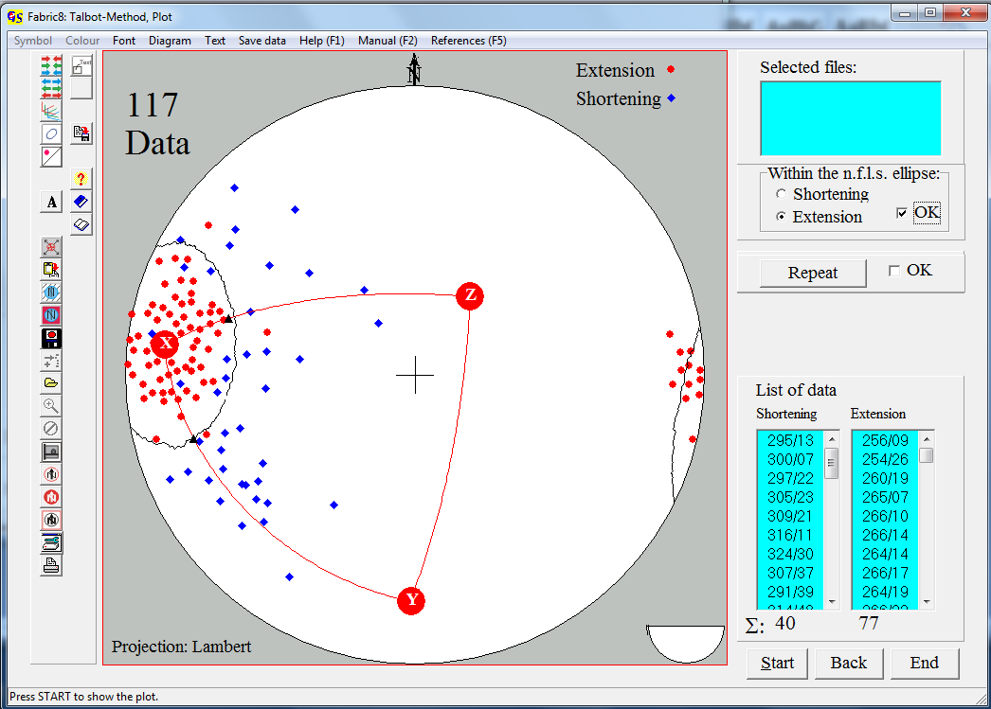
Fig. 6

When you clicked on both points the ellipse is drawn (Fig.6), and the panel “Repeat/OK” becomes visible (Fig.7).


Fig. 7

Press “Repeat” when you can optimize the ellipse. Finally click “OK”.
Now the axial ratios X/Y and Y/Z are calculated and the button “Flinn diagram” appears (Fig. 8).
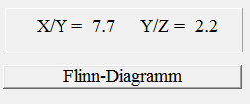
Fig. 8

Fig. 9 shows the Flinn diagram.

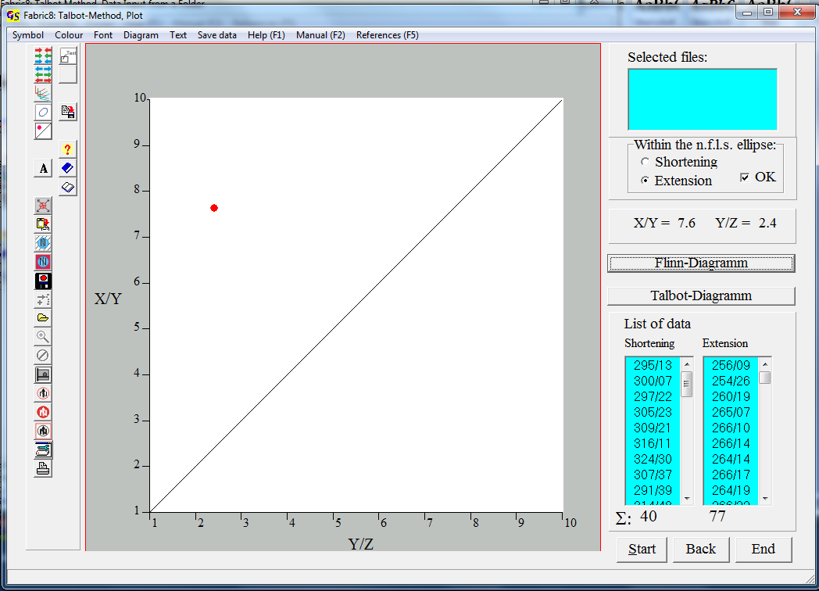
Fig. 9

With the button “Talbot diagram” you can jump back to the previous diagram.

All menus are the same as in the other programs.

